**Mediumish** is a Jekyll template, designed for Medium’s website design fans. Thus it’s clean, minimal, beautiful and modern! This post is about the **Jekyll template** version but there are also 3 more versions of this template: [HTML Version](https://www.wowthemes.net/mediumish-free-bootstrap-4-0-html-template-medium-styled/), [WordPress Version](https://www.wowthemes.net/themes/mediumish-wordpress/), [Ghost Version](https://www.wowthemes.net/themes/mediumish-ghost/)

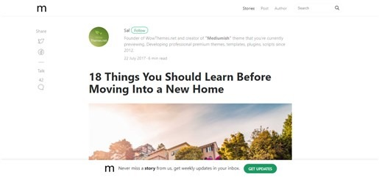

**Mediumish Jekyll Template - Features**

* Built for Jekyll
* Compatible with Github pages
* Featured Posts
* Index Pagination
* Post Share
* Post Categories
* Prev/Next Link
* Category Archives (this is not yet compatible with github pages though)
* Jumbotron Categories
* Integrations:
  + Disqus Comments
  + Google Analaytics
  + Mailchimp Integration
* Design Features:
  + Bootstrap v4.x
  + Font Awesome
  + Masonry
* Layouts:
  + Default
  + Post
  + Page
  + Archive

**What is Jekyll**

If you aren’t familiar with Jekyll yet, you should know that it is a static site generator. It will transform your plain text into static websites and blogs. No more databases, slow loading websites, the risk of being hacked, just your content! And not only that, with Jekyll you get free hosting with GitHub Pages! If you are a beginner we recommend you start with [Jekyll’s Docs](https://jekyllrb.com/docs/installation/). Now if you know how to use Jekyll, let’s move on to using Mediumish template in Jekyll:

**Using Mediumish In Jekyll**

* In your local project, open _config.yml. If your site is in root, for baseurl, make sure this is set to baseurl: /. Also, change your Google Analytics code, disqus username, authors, Mailchimp list etc.
* Mediumish requires 2 plugins:
  + $ gem install jekyll-paginate
  + $ gem install jekyll-archives.
* Edit the menu and footer copyrights in default.html
* Start by adding your .md files in _posts. Mediumish already has a few as an example.
* YAML front matter
  + post featured - featured:true
  + post featured image - image: assets/images/mypic.jpg
  + page comments - comments:true
  + meta description (optional) - description: "this is my meta description"

YAML Post Example:

---

layout: post

title: "We all wait for summer"

author: john

categories: [ Jekyll, tutorial ]

image: assets/images/5.jpg

featured: true

---

YAML Page Example

---

layout: page

title: Mediumish Template for Jekyll

comments: true

---